CSED: Computer Vision (Assignment 3) Stereo Vision – Part 1: Block Matching

Contents
- Introduction 2
- Implementation Details 2
  - Cost Metrics . . . . . . . . . . . . . . . . . . . . . . . . . . . . . . . . . . 2
  - Experimental Parameters . . . . . . . . . . . . . . . . . . . . . . . . . . . 2
- Results and Discussion 2
  - Observation on Window Size (w) . . . . . . . . . . . . . . . . . . . . . . 3
  - Observation on Metrics (SAD vs. SSD) . . . . . . . . . . . . . . . . . . . 3
- Conclusion 3

1

Introduction
The objective of this assignment, as specified was to implement a simple dense stereo depth estimation algorithm: Block Matching. Using a forward-facing camera setup trans-lated along the horizontal axis, we compute the horizontal disparity for pixels along each scanline. Disparity is inversely proportional to depth; objects with high disparity (large horizontal shift) are interpreted as being closer to the camera.

Implementation Details
As required, the solution was implemented in Python using numpy for numerical array operations and cv2 (OpenCV) for basic image I/O.

Cost Metrics
We implemented two mathematical metrics for measuring window similarity:
    - SAD (Sum of Absolute Differences): A computationally fast metric that sums the absolute pixel-wise differences between windows.
Cost_{SAD} = .L |I_{l}(i, j) − I_{r}(i, j − d)| (1)
(i,j)∈W
    - SSD (Sum of Squared Differences): A metric more sensitive to large outliers due to the squaring operation.
Cost_{SSD} = .L (I_{l}(i, j) − I_{r}(i, j − d))² (2)
(i,j)∈W
Here, W is the matching window of size w, and d is the disparity shift being evaluated.

Experimental Parameters
We tested the block matching algorithm across six scenarios:
- Window Sizes: w = 1, 5, 9.
- Metrics: SAD and SSD for each window size.
- Maximum Disparity: A maximum horizontal search range of 64 pixels was uti-lized.

Results and Discussion
The generated output maps, visualized using the ’jet’ colormap, are presented in Figure
1. Warmer colors (reds, yellows) represent higher disparity (near objects), while cooler colors (blues) represent lower disparity (far background).

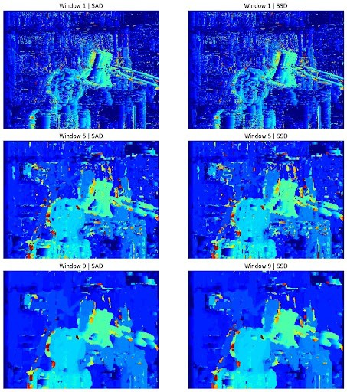

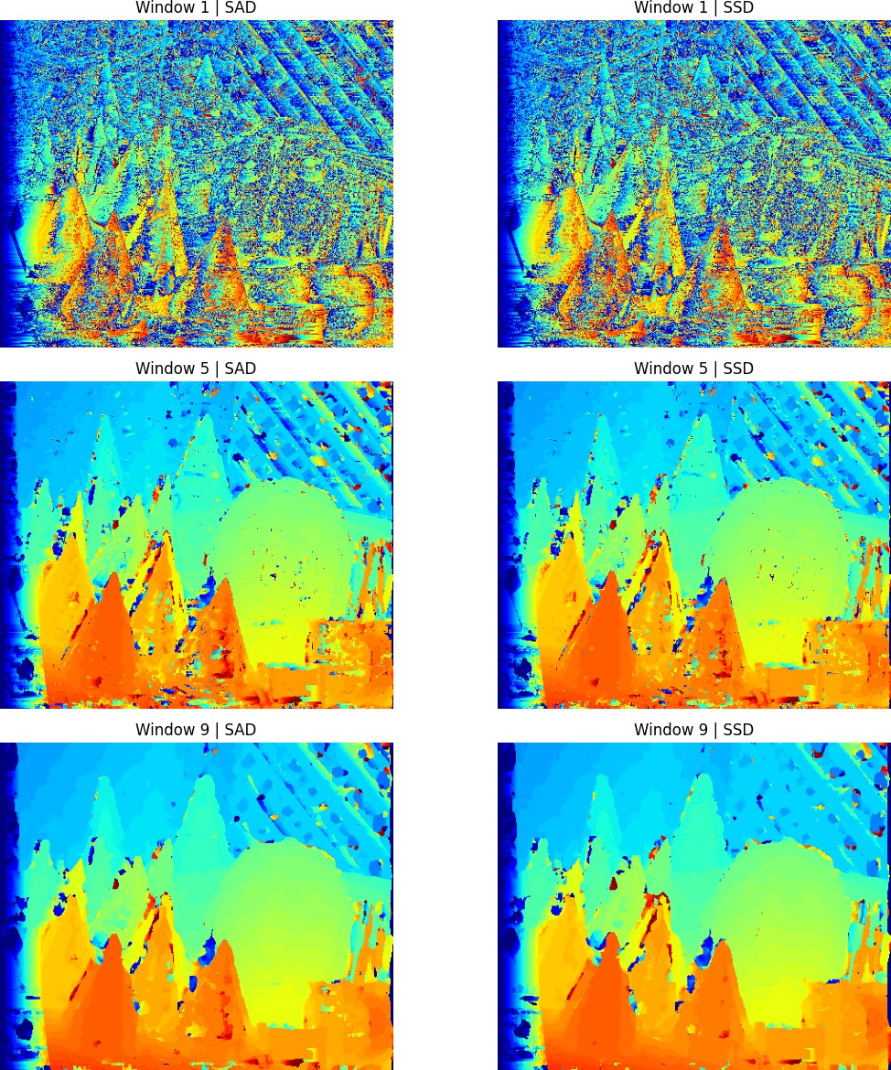

Observation on Window Size (w)
w = 1 (Top Row): These maps show significant salt-and-pepper noise. A single pixel is highly sensitive to sensor noise, leading to multiple incorrect best-cost matches.
w = 5 (Middle Row): Noise is significantly reduced, and the relative depth of the foreground figure becomes coherent.
w = 9 (Bottom Row): The maps are the smoothest and clearest. However, a common artifact of large windows—object boundary ”fattening” or blurring is observed, particu-larly around the edges of the main figure. There is a trade off between noise reduction and edge precision.

Observation on Metrics (SAD vs. SSD)
The results for SAD (left column) and SSD (right column) are visually nearly identical for this dataset. This is likely due to consistent lighting between the left and right images. While SSD is theoretically more sensitive to large outliers (noise), its results here did not differ substantially from the simpler SAD metric.

Conclusion
In this part of the assignment, we successfully implemented and visualized simple block-based stereo vision. The experiments highlighted the fundamental trade-off of window selection: larger windows reduce pixel noise but degrade depth boundary precision. Both SAD and SSD provided effective results for basic horizontal disparity estimation.

